| **Greenwell Project**  **Software Design Description**  **Version 3.0**  **04/26/2023**  **Quality Assurance Team** |
| --- |

Caleb Jenkins, Kylie Hall, Yaro Kulchyckyj, Matthew Grimelli

**Table of Contents**

1. Introduction **1**

1.1 Purpose 1

1.2 Scope 1

1.3 Definitions, Acronyms, and Abbreviations 1

1.4 References 2

1.5 System Overview 2

2. Data Design **2**

2.1 Internal Data Structures 2

2.2 Data Flow Diagram 2

2.3 Data Dictionary 2

3. Architecture Design **3**

3.1 Program Structure 3

4. Interface Design **3**

4.1 Internal System Interfaces 3

4.2 External System Interfaces 3

4.3 User Interfaces 3

4.3.1 Log in Screen 3

5. Procedural Design 4

5.1 Flowchart Reference Key 4

6. Miscellaneous **4**

**Revision History**

| **Date** | **Version** | **Description** | **Author(s)** |
| --- | --- | --- | --- |
| 9/20/2022 | 1.0 | Created Template for use | Eythan Jenkins |
| 12/07/2022 | 2.0 | Fall 2022 | QA Team |
| 04/26/2023 | 3.0 | Most Recent Version | Caleb Jenkins, Kylie Hall, Yaro Kulchyckyj, Matthew Grimelli |

# 1. Introduction

## 1.1 Purpose

The Software Design Description (SDD) is a comprehensive software design model consisting of four distinct but interrelated activities: data design, architectural design, interface design, and procedural design. The document is used as a tool to communicate preliminary design concepts to customers, users, and the software engineering team members.

The Data Design describes structures that reside within the software. Attributes and relationships between data objects dictate the choice of data structures.

The Architecture Design uses information flow characteristics, and maps them into the program structure. Transformation mapping method is applied to exhibit distinct boundaries between incoming and outgoing data. The Data Flow diagrams allocate control input, processing, and output along three separate modules.

The Interface Design describes internal and external program interfaces as well as the design of human interface. Internal and external interface designs are based on the information obtained from the analysis model.

The Procedural Design describes structured programming concepts using graphical, tabular, and textual notations. These design mediums enable the designer to represent procedural detail that facilitates translation to code. This blueprint for implementation forms the basis for all subsequent software engineering work.

## 1.2 Scope

The SDD will relate most closely to the actual development of the software. The final product should follow and reflect the finalized version of this document.

The SDD contains the following sections:

* Data Design
* Architecture Design
* Interface Design
* Procedural Design

## 1.3 Definitions, Acronyms, and Abbreviations

| SDD | Software Design Description |
| --- | --- |
| SDP | Software Development Plan |
| SMCM | St. Mary’s College of Maryland |
| SRS | Software Requirements Specification |
| STP | Software Test Plan |
| TBD | To Be Determined |
| TM | Traceability Matrix |

## 1.4 Document References

This section is currently not applicable.

## 1.5 System Overview

This system will be an internet hosted database used by board members and trustees of the Greenwell Foundation. The intended use of this database is to replace their current content distribution and organization system with a centralized, proprietary solution. To accomplish this, the website must facilitate the uploading and downloading of documents, videos and photos. The website must also have an intuitive method of version control and segmenting of different types of content. The team must also decide how and where the website will be hosted by request of the customer.

# 2. Data Design

This section outlines all data structures to be implemented and how they should be implemented. Reference section 6 for more information on Wordpress plugins as discussed within this section.

## 2.1 Internal Data Structures

| **Plugin** | **Description** |
| --- | --- |
| Elementor | A page builder plugin for Wordpress used to build and design various pages. |
| LoginWP | A plugin used to redirect users to a specific page after they log in. COSC 402 has created rules to increase secureness of access to specific pages and information within the website. The software will send a user to a specific page based on their user role and shared file restrictions. |
| Theme My Login | Used to set up basic login and register page forms. It also determines if users can use their Username or Email or both to register or login to the website. |
| User Role Editor | Used to change default user roles and gives users the assigned capabilities linked to such assigned role. |
| WP File Manager Pro | Used to create the Shared File Manager Window. It controls the restrictions for each role and allows users to perform file management tasks from the Wordpress website. |

## 2.2 Data Flow Diagram

Data flow diagrams describe the relationship between hardware and software devices, and the information each can communicate to each other. 

# 3. Architecture Design

The architecture design outlines the hierarchy of the program, as well as indicating coupling relations between modules.

## 3.1 Program Structure

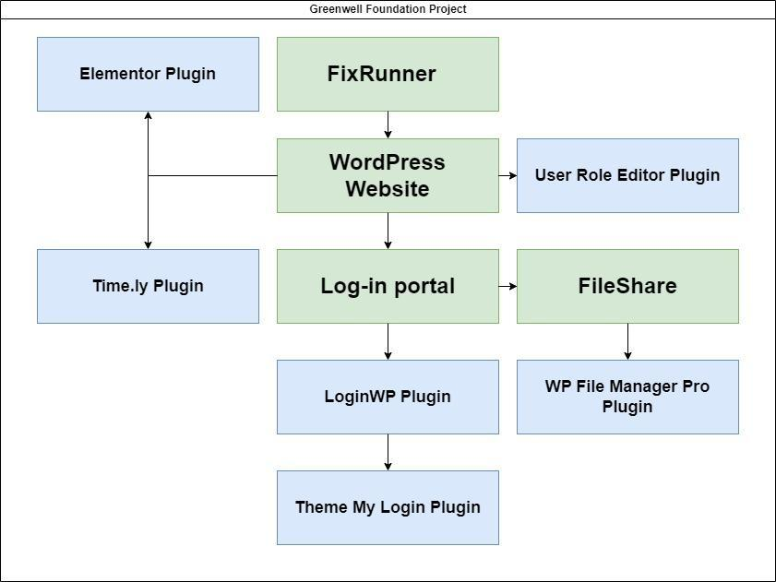

# 4. Interface Design

The interface designs contain internal, external, and user interfaces. These are designed to expand upon the architecture model and to further depict visual and operational interfaces.

## 4.1 Internal System Interfaces

The software will not utilize any internal system interfaces, therefore this section is not applicable.

## 4.2 External System Interfaces

The software will not utilize any external system interfaces, therefore this section is not applicable.

## 4.3 User Interfaces

#### 4.3.1 Log in Screen

The log-in screen can be accessed at the bottom of the home screen by clicking on the “Board/Staff Login” button. The user will then be presented with a prompt to enter their username and password. If they do not currently have an account then they can click the “Register” button. If the user has forgotten their password then they can click the “Forgot Password” button to start the password reset process using the email address they registered with. The user also has the choice to check the “Remember Me” box so their username and password isn’t forgotten by the system. Once the “Log in” button is clicked the user will have access to the File Manager.

#### 4.3.2 File Manager

The file management software will open to the folder system. The user can now add and view files within the file manager.

# 5. Procedural Design

Our team has constructed several flowcharts to facilitate programmer and customer understanding of the usage of the program. Processing flow is depicted for all requirement functions.

## 5.1 Flowchart Reference Key

## 



# 6. Miscellaneous

**2.1** A Wordpress plugin is a piece of software that plugs into the wordpress website. It allows more functionality and features that are not allowable by default.